1. Draw a simple diagram showing the main components of a food delivery app like Zomato or Swiggy (such as user, restaurant, order, delivery partner, payment) and label how they interact in the software architecture.
Ans
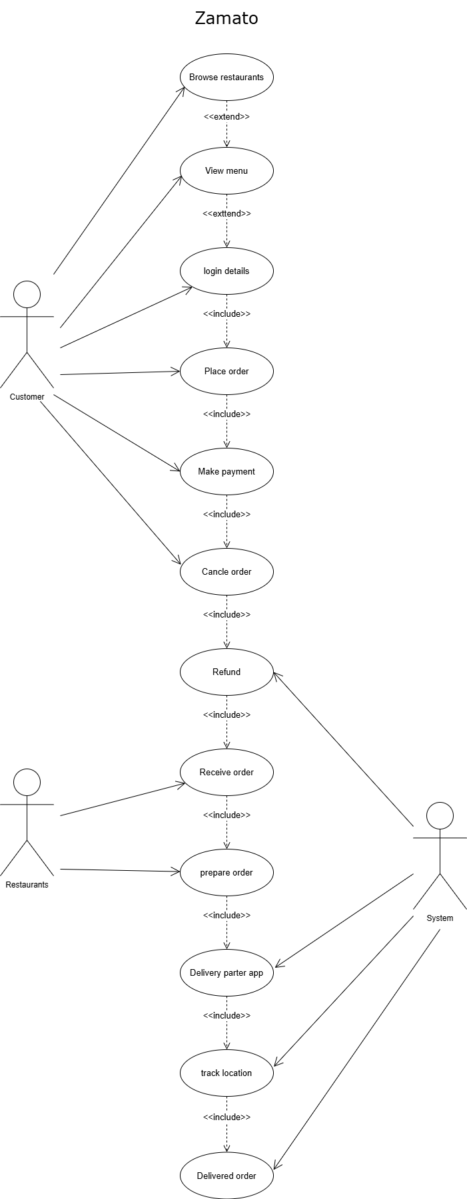
2 . Pick any app you use daily (Instagram, Paytm, Flipkart, etc.) and list 5 different testing activities that must be performed before the app is released to users.<br><br><em><strong>Hint:</strong> Think about things like login, payment, notifications, speed, and security.</em>
Ans
I'll pick Flipkart (e-commerce app) since it involves a lot of moving parts — payments, inventory, logistics, and a huge user base — which makes for good testing examples.
1. Functional Testing
Verify that core features work exactly as intended — searching for products, adding items to cart, applying coupon codes, checking out, and placing an order.
2. Payment Gateway / Integration Testing
Since Flipkart integrates with multiple payment methods as UPI, credit/debit cards, net banking, wallets, EMI, Cash on Delivery, each of these needs to be tested end-to-end.
3. Performance & Load Testing
This checks how the app behaves under heavy traffic, especially during sale events like the "Big Billion Days." Testers simulate thousands of concurrent users browsing, adding to cart, and checking out simultaneously to ensure the app doesn't crash, pages load within acceptable time, and servers can handle peak load without slowdowns.
4. Usability and UI/UX Testing
This evaluates how intuitive and easy the app is for real users — is the navigation clear, are product filters easy to use, is the checkout process simple with minimal steps.
5. Compatibility Testing
Test the app on different Android and iOS devices, screen sizes, and operating system versions to ensure it works properly for all users.
6. Security Testing
Given that the app handles sensitive data (passwords, addresses, payment/card details), security testing checks for vulnerabilities like data leaks, insecure API endpoints. This also includes testing login/logout flows and ensuring saved card details are tokenized rather than stored in plain text.

3. Explain in your own words why testing is important at each stage of the Software Development Life Cycle (SDLC), using an example from an app like BookMyShow or IRCTC.
Ans
The Software Development Life Cycle (SDLC) is a structured process that defines how software is planning, create, implementation, testing, and deployment. Let me walk through each stage using IRCTC (the Indian Railways ticket booking platform) as the running example.
- Requirements Analysis =
Testing here means reviewing the requirements themselves for completeness, consistency, and feasibility — before a single line of code is written.
Example = Users can book tickets up to 120 days in advance, verify that the requirement correctly states users can book train tickets, cancel tickets, and receive refunds according to railway rules.
- Design =
During design, architects map out the database, user interface, and server structure. Testing here involves reviewing the architecture for scalability, security, and usability.
Example = If the design proposes a single database instance handling both search and booking, a design review might flag that this won't scale for Tatkal traffic spikes, prompting a switch to a queuing system or read replicas before any code is built around the flawed design.

- Implementation =
Developers perform unit testing to ensure each function and modules are works correctly.
Example = Test the fare calculation module to confirm it correctly calculates ticket prices based on class, distance, and passenger category. A developer writes a function that calculates cancellation fees based on how much time is left before departure. The payment gateway module and the seat-booking module might each work perfectly alone.
- Testing =
Here the entire application is tested end-to-end against the original requirements, including performance, security, and usability testing.
Example = Test the full booking process—from user login, train search, ticket booking, payment, and ticket generation—to verify the entire workflow functions smoothly. Simulating a full Tatkal booking rush — thousands of concurrent users searching, selecting berths, and paying — to see if the system holds up under real load, and whether the UI remains usable when a train fills up mid-search.
- Deployment =
When the software goes live, the team performs User Acceptance Testing (UAT). This ensures the live environment is stable and real users can achieve their goals.
Example = After deploying an update, a smoke test would verify that basic flows (login, search, book, pay) work in production before opening it to millions of users — catching, say, a misconfigured production database connection before it becomes a nationwide outage.

- Maintenance =
After deployment, testing ensures updates, bug fixes, and new features do not introduce new problems.
Example = The development team adds a new feature allowing users to pre-book a "Vande Bharat" special meal. Regression testing is required to ensure that adding this meal option didn't accidentally break the standard process for downloading an e-ticket.

4. Write down the main objectives and purpose of testing by imagining you are part of a team launching a new music streaming feature in Spotify. List at least 3 objectives and explain each in one line.
Ans
Our team is about to launch a new feature which is " 90 playlist radio " feature in Spotify, here are the main objectives of testing.

1. Ensure the feature works correctly = Confirm the feature works exactly as intended and verify that users can play, pause, skip, and stream songs without errors.
2. Ensure a seamless user experience = Check that the feature is fast, easy to use, and responsive on different devices as a mobile, desktop.
3. Verify performance under load = Ensure the new feature works properly even when millions of users access it same time.

